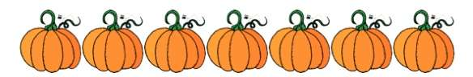

Hello Parents of Room ABC,

Our Fall Party is just around the corner…it is scheduled for October 31. I will be making treat bags for the children to take home from the party that day. If you would like to donate candy or any other items for our Fall treat bags, please send them in to school with your child no later than October 28. Please send in your donation to me so that we can combine everything and only one treat bag can be sent home. Any type of donation is greatly appreciated….candy, pencils, erasers, rings, toys, etc! There are 22 students in Mrs. Teacher’s class. No allergies have been noted for our class this year.

Parents are invited to watch the Parade from the front of the building. The Parade will start around 2:20 pm and will be in the parking lot and sidewalks in front of the school. Only Party Helper Parents will be permitted to enter the building after the Parade.

Should you have any questions, please feel free to contact me at any time!

Thank you,

Your Name
(412) 123-9123
email@gmail.com

